JUNIT OUTPUTS:

Junit exercise 1:

No output, only changes to pom.xml

Junit Exercise 3:

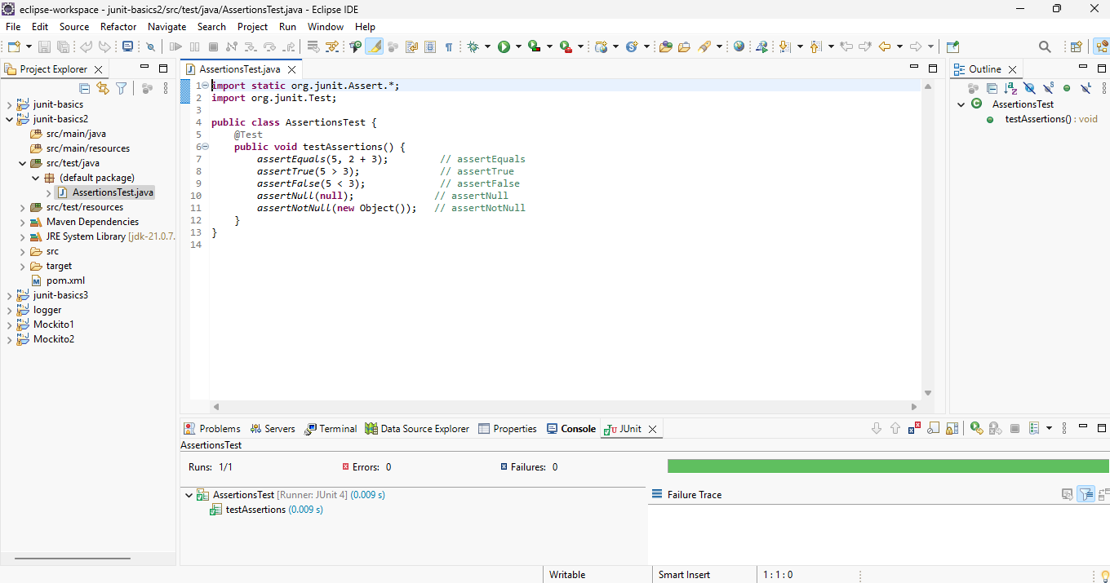

Junit Exercise 4:

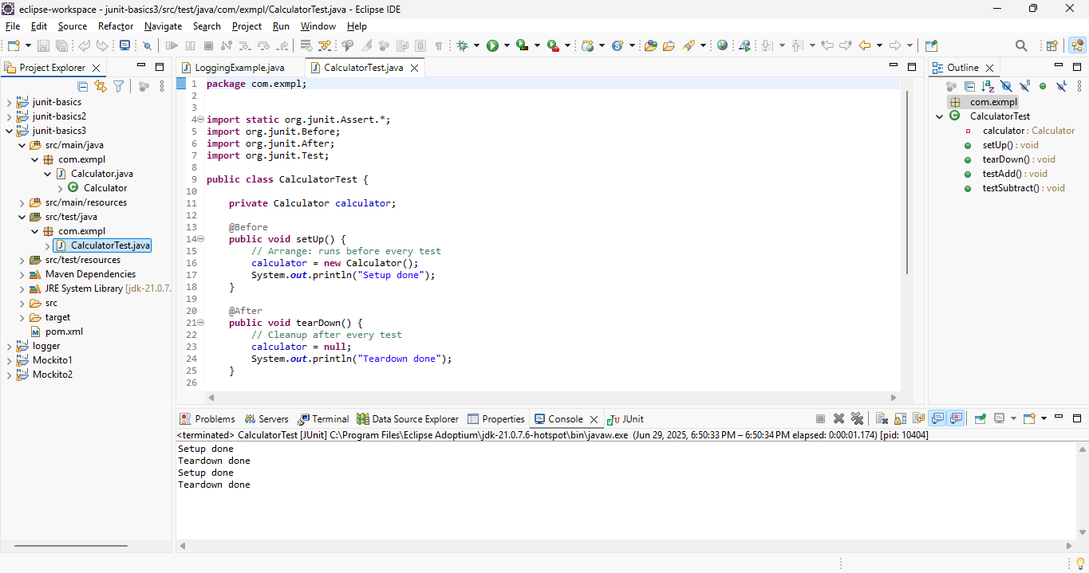

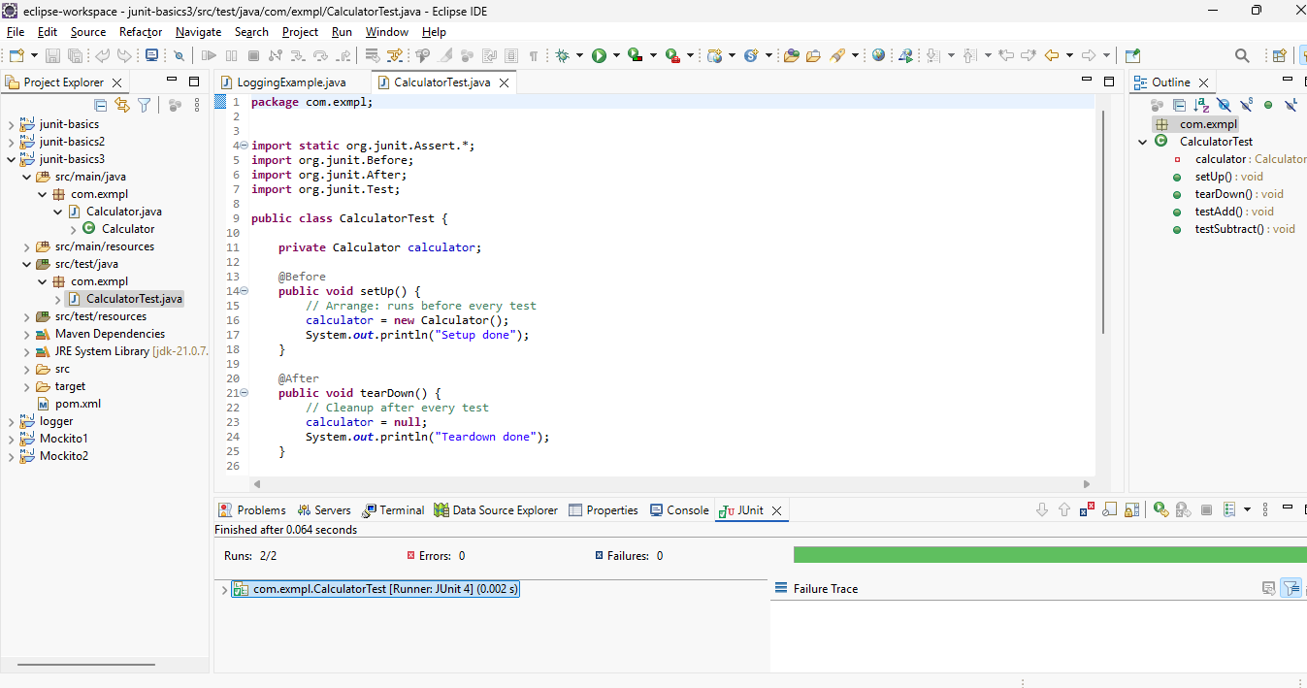

Mockito Exercise 1 :

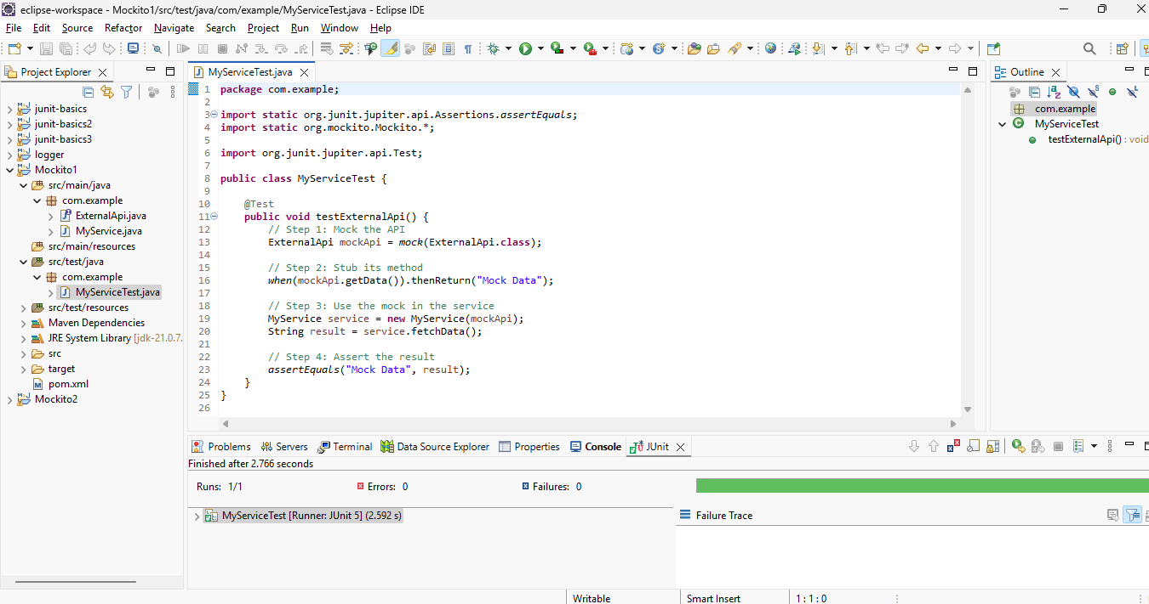

Mockito Exercise 2:

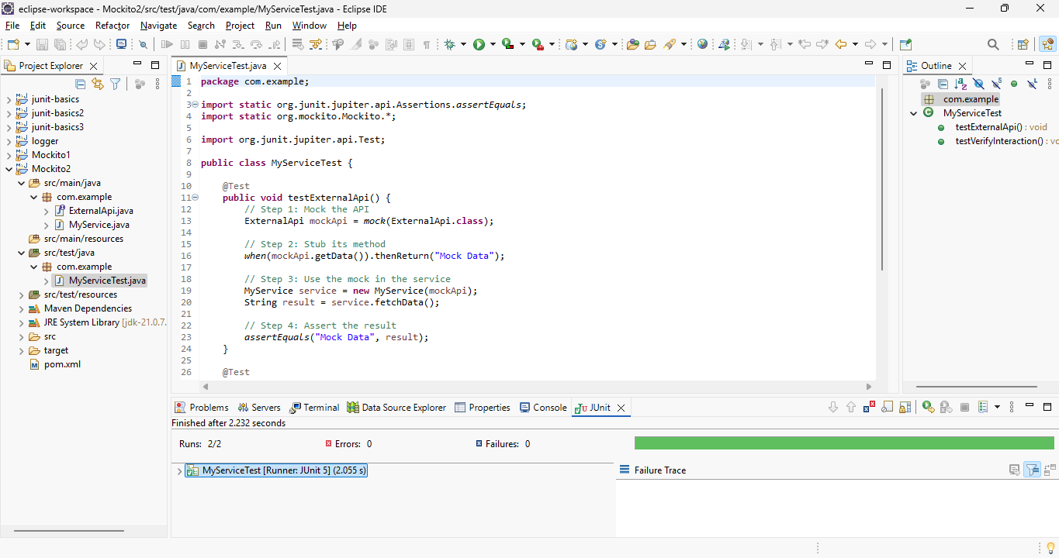

Logger Exercise 1:

